COLOUR STRIP

STP2 Stage 1 Quick Guide

COLOUR STRIP

**© Copyright 2023 Mastergroup (Aust.) Pty Ltd**

**All rights reserved. No part of this Training Manual may be reproduced, stored in a retrieval system, or transmitted in any form or by any means, electronic, electrostatic, magnetic tape, mechanical, photocopying, recording or otherwise, without permission in writing from the author.**

|  |
| --- |
| **Checklist** |
| Latest version of Wagemaster. |
| Company Details are correct. |
| Employee Details are correct. |
| Create new folder named STP2 |
| Check/Update Tax tables. |
| Update Flat rate with SWP or ATO defined (if applicable) |
| Check/Update Employment categories |
| Export/save |
| Export/save |
| Map Tax treatment |
| Map Allowances |

**PRELIMINERY CHECKS/UPDATES**

Create a STP2 Folder – save all resources associated with STP2 here.

1. Check File location is set to Default by the checkboxes being ticked.



**Setup > Preferences > Configuration > File location**



1. Check Company details.

**File > Company Details**

update if necessary, using the HR licensing Wizard by selecting **Change company details.**



1. Update Name(description), if applicable for Flat rate tax tables.

**Setup > Tax > Table >** select the relevant flat rate and edit.

* Seasonal Worker Flat Rate – 25%
* ATO Defined Flat rate - 45%

1. Check and update (if applicable) Intermediary section.

**File > Company details > Taxation > Single Touch Payroll**



**EXPORT FILES/REPORTS**

1. Export 3 files

**HR > User Defined > Company Employee Award Department Category Payrate**.

You must review the report and ensure all employees are listed as **Full time, Part time or Casual.**



To make changes, go to: **Employee > choose employee > Employment.**

**HR > User Defined > Employee Tax Tables**

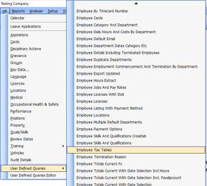

* Fill in Query Parameters

Financial year **2023**

From date – **01.07.2022**



To date – **30.06.2023**

* **Save Icon > Excel.**



* **Save to STP2 Folder**

**HR > User Defined > Allowance Taxed and Super Calculation Status**

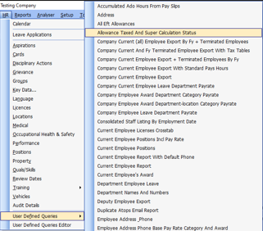

* **Save Icon > Excel.**



* **Save to STP2 Folder**

**TAX TREATMENT**

1. Open **Tax treatment Mapping tool** and Exported Employee **tax table report**.

* **Copy** the data from the **tax table report** by using **Ctrl C** – the area selected will be grey as per diagram to the right.
* In the **Tax treatment Mapping tool:**
* Table

  Description automatically generated with low confidenceRight click on the first tab named Your Company details and rename.
* Next place the cursor in the first available empty cell usually A2 then use **Ctrl V to paste.**

You now need to map out the red headings.

1. **Every Item MUST have a tax treatment allocated.**

Ttreatment = Tax Treatment . Use the drop-down arrow and select the appropriate Tax Treatment for every employee.

Income Types and Tax Treatment

**SAW =** Salary & Wages

**CHP =** Closely Held Payee

**WHM =** Working Holiday Maker

**SWP =** Seasonal Workers Program – tax table that is a flat rate of 15%

1. **Any item with the STP2 Ttreatment group SAW or CHP you MUST have a tax item (second column) allocated.**
2. **If you selected Senior in the tax item (second column), you must also select in the Senior column (third column).**
3. **If any employees require Half or Full Medicare Levy, then select YES from the drop down in the 4th and 5th red columns.**
4. **Lass column, record the number of dependents the employee is claiming if applicable.**

**CORRECT ALLOCATION**

To ensure correct allocation of Tax Treatment, the employees Tax Table setup must be correct.

Most employees will be Income Type SAW with Tax Treatment of Regular. This will be set from the Tax Table assigned to the employee.

Seniors, Working Holiday Makers, and Foreign Residents will also be set automatically from the employee’s tax table allocation.

For other Income Type/Tax Treatment

WHM - ensure employees are linked to Working Holiday Maker tax table.

With release of STP2 enabled software, additional option for Employer WHM registration will be required.





For Seasonal Workers, the user defined tax table setup description MUST start with **Seasonal Worker**

e.g.

For ATO Defined (Downwards Variation), the user defined tax table setup description MUST start with **ATO Defined** e.g.



**ALLOWANCES**

1. Open Allowance mapping tool and exported report on allowance taxed and super calculations.

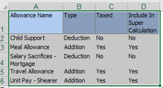

* **Copy** the data from the **allowance report** by using **Ctrl C** the area selected will be grey as per diagram to the right.

In the **Allowance Mapping tool**:

* Table

  Description automatically generated with low confidenceRight click on the first tab named Your Company details and rename.
* Next place the cursor in the first available empty cell usually A2 then use **Ctrl V to paste.**

You need to map out the red headings.

1. **Every item MUST have an STP2 Reporting group.**
2. **Any item with the STP2 reporting group of**

**Allowances, Lump Sum, Superannuation or Leave,**

**MUST have an STP2 Subgroup.**

1. **Any item with the STP2 subgroup of Other Allowance,**

**MUST have an STP2 Other Allowance Description entered.**

1. **All items require OTE to be marked Yes or No**

The below diagram is a Visual guide in options available for selection.